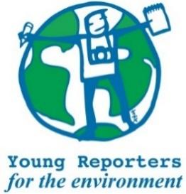

**YRE International Competition**

**Competition entry form 2024/2025**

**Category: Photo Story (3-5 photos)**

*Questions marked with * must be answered.*

|  |  |
| --- | --- |
| **Name of student(s)\*** |  |
| **Age(s) of students as of National Competition deadline\*** |  |
| **Name of school\*** |  |
| **Town and Postcode of school\*** |  |
| **Title of the submission (within 140 characters)\*** |  |
|  |  |
| **Is the title within 140 characters?\*** |  |
| **Does the photo story have a short introduction of max. 100 words that explains the link with environmental sustainability and/or a solution to the issue?\*** | ☐ Yes / ☐ No |
| **Does each photo have a short caption of max. 20 words?\*** | ☐ Yes / ☐ No |
| **Are the photos a fair and truthful representation of reality and the subject and/or scene has not been manipulated or altered?\*** | ☐ Yes / ☐ No |
| **Do the photos and/or descriptions/captions include relevant and feasible solutions to the environmental issue presented in the photos?\*** | ☐ Yes / ☐ No |
| **Are the sources used in the description and/or captions cited in footnotes or** [**MLA style**](https://subjects.library.manchester.ac.uk/referencing-new/mla)**?\*** | ☐ Yes / ☐ No |
| **Are the original photos attached separately digitally as .jpg or .png format with a resolution of** [**no less than 150-300 dpi**](https://dpi.tools/image-dpi-checker)**?\*** | ☐ Yes / ☐ No |
| **Where has the submission been disseminated?\*** | ☐ Personal Sphere (through social media such as Instagram, Twitter, YouTube, or a personal blog)  ☐ School Community (through the school newspaper, website, or as a poster or flyer in the school building.)  ☐ Eco-Schools NI (through the organisation's website or social media channels)  ☐ National Media (through newspaper, TV, radio)  ☐ Other |
| **Please attach or list evidence of dissemination (links and/or photos) that show where your submission was shared with others.\*** |  |
| **Student’s brief explanation of how the submission topic is linked to at least one of the UN Sustainable Development Goals\***  **You can read about the SDGs here: https://sdgs.un.org/goals** |  |